# Whitworths in Austria

I've had several people ask me, and yes, the hills WERE alive in Salzburg, Austria! The mountains, the crisp, cool air, the flowers, the people, . . . everything was just profoundly stunning.  We had a wonderful time for 5 days, sampling music, food, theater, culture, and nature.

Day One (Oct 5th):

During our 5 hour drive to Salzburg, we stopped just north of Villach, Austria for lunch. Amber found us a McDonald's that was close to the freeway, and it turned out to be really cute! The restaurant had an upstairs with a play area for the girls, which they loved. It was surprisingly very quiet and peaceful up there. Amber noticed right away that the German/Austrian demeanor is much more reserved than the Italians. The parents were all very quiet, they spoke quietly to their children, and the children were pretty quiet, too, even though they were clearly having fun playing when they weren't eating.

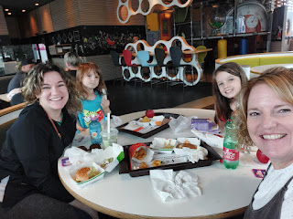

The Austrian Alps were so magnificent . . .

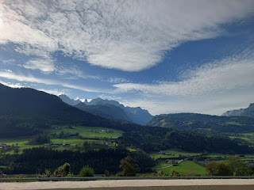

Our AirBnB was one of the best ones I've ever stayed in. We had the entire house, with 2 bedrooms downstairs, 2 bathrooms, a nice big kitchen, and a living room with 2 very plush reclining lounge chairs that also served as comfortable beds at night. It was very modern and clean and classy.

This was the view from our rooftop terrace, looking toward the Untersberg Mountains. On this side of the mountains is Austria, and on the opposite side is Germany - specifically the Berchtesgaden, Germany area, which I will share more about below. (Berchtesgaden = berhk-tez-gad-n)

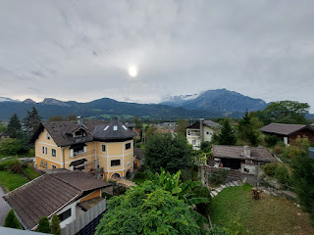

Looking north from the terrace, there was a cheerful yellow Austrian house, my favorite color. :)

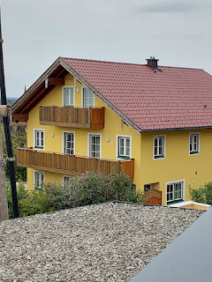

After we got situated, we decided it would be a good idea to figure out the public transportation system and practice getting ourselves into the actual city of Salzburg, since we were in a little town on the southern outskirts, called Puch-Hallein.

It was only a 5 minute walk to get from our AirBnB up on the hill, down to the bus stop. The girls enjoyed picking wildflowers and running up and down the hill next to the stop while we waited for the bus to come.

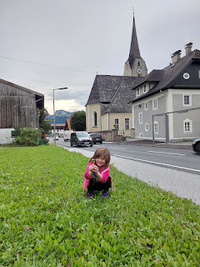

We used cash to pay for this first run into town, since we didn't like the app that we found online. It cost us 12.50 euros for the 4 of us to go one-way into Salzburg. Turns out that it was more than what we should have paid, since Gwen should have been free, and we also later learned that an all-day bus pass was a much better deal. It took us about 35-40 minutes to get into town and navigate through traffic to Mirabell Gardens, in the heart of Salzburg.

Me, Abby, Gwen, and Amber while we waited for the bus. (Scott would be there in a few hours, separately.)

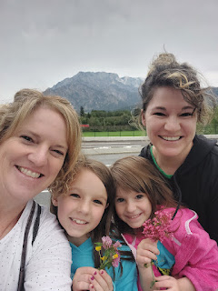

Mirabell Gardens has so much to offer: trees to climb, walking trails, huge gardens, and a few hidden gardens.

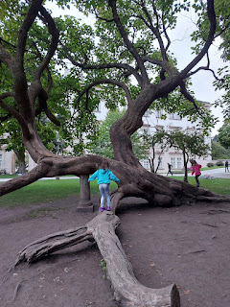

It also happens to be one of the filming locations for The Sound of Music, where they filmed the Do-Re-Mi scenes.

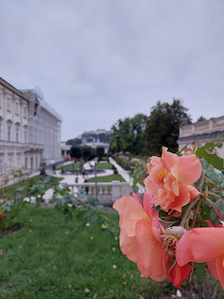

A hidden garden that we found was called Zwergelgarten, also known as the Dwarf Garden.

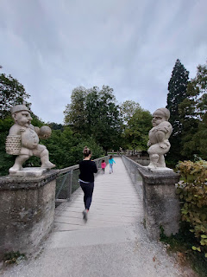

Created in 1715 by the Prince Archbishop, and fashioned after some locals and peasants, the marble dwarves are both whimsical and occasionally creepy, ha ha. I enjoyed it all very much, as did Abby and Gwen.

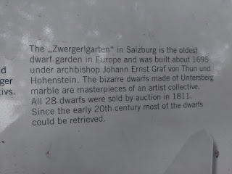

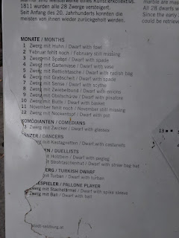

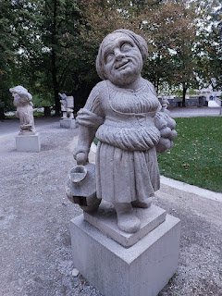

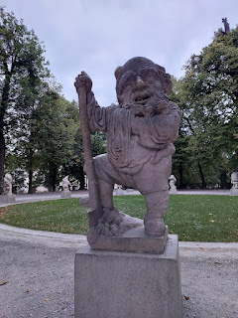

Soon, the sun was setting and we decided to head back to the house and settle in for the night. We had a big day coming up . . .

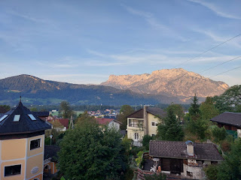

Scott arrived around 9 pm. He drove separately because he could only stay for 2 days because of some church responsibilities back in Vicenza.

Day Two (Oct 6th):

We had learned the night before that we could just use our Visa to get bus tickets into town, instead of paying with cash. Scott opted to get us a full day pass, which saved us quite a bit of money. Everyone is very patient in Austria, which was nice, because there are multiple scenarios for all of the passengers boarding the bus. Some would just quickly flash the driver a QR code on their phone, or they showed him a card in their wallet, while some paid with cash or a credit card, like we did. The driver was always very friendly and accommodating to everyone.

Video of our walk down to the bus stop: (15 seconds)

https://photos.app.goo.gl/fAjVGGSPd8zQgp476

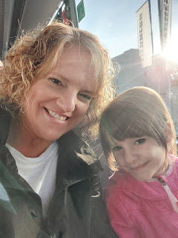

We arrived at the meeting spot for our Sound of Music Tour without a hitch, which was also right across the street from Mirabell Gardens, the place we had already scouted out the night before.

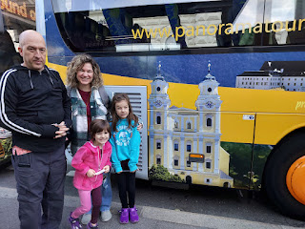

Our guide's name was Mitch, and he was HILARIOUS. The tour was a mixture of stories, history, and comedy that he shared during our 4 hours with him on and off the bus.  He was from New Zealand, which also added another layer of fun as we listened to his entertaining accent.

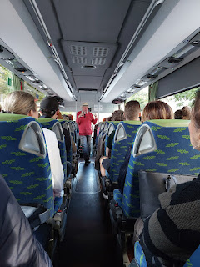

The first stop was at the lake, where the boat scene from The Sound of Music was filmed.

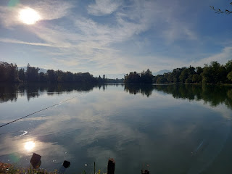

A small clip of our animated guide, Mitch: (11 seconds) He joked several times that he throws children into the lake . . . so Abby and Gwen were a little skeptical of him . . . ha ha

https://photos.app.goo.gl/dRCQRRwvKW4VmbjL9

He told us a story of how Liesl was deathly afraid of going in the water, and how she feared she would surely drown. They had divers nearby in the water as an added safety measure, and yet each time they had to re-take the scene, Liesl was getting more and more upset and anxious. Julie Andrews, as Maria Von Trapp, decided to have a little fun during one of the film takes. She stood up in the boat and began making it rock back and forth. While every other practice run involved the children falling out in one specific direction, this time it went a little differently . . . they all went overboard in different directions, which caused a momentary panic for those overseeing the action. But the director had the cameras still running!! It ended up being the perfect scene and this is what ended up going into the movie. No one drowned and all turned out fine.

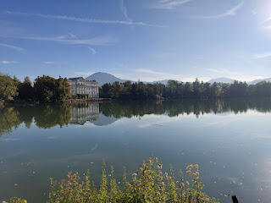

We passed a few Schlosses (palaces, fortresses, or castles) as we drove around from place to place. This massive Schloss is known as Schloss Hohensalzburg, and was built in the 11th century!!

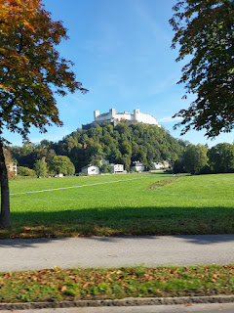

Cute Gwennie, posing before we boarded the bus again . . .

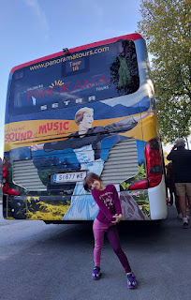

The gazebo that was used in the movie, especially for the scene with Liesl and Rolf singing, "I Am 16 Going on 17", had to be moved to a new location for all the thousands of fans who flocked to see it. It used to be at the house on the lake, but that house was organized into an educational academy for orphans after WWII, so the estate needed to be a bit more peaceful for their studies. Locals had it moved it over to Hellbrunn Palace, where all the superfans could see it anytime they want.

Like us . . .

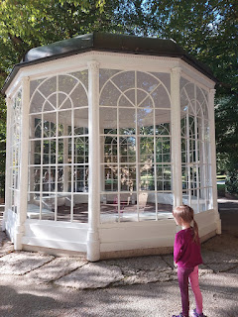

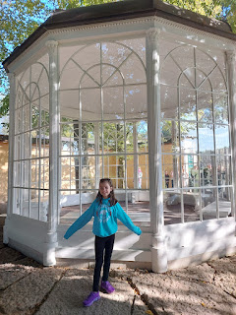

Gwen, Amber, Abby, and Me

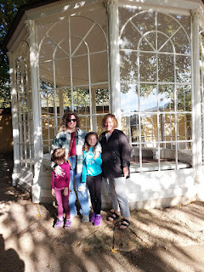

Mitch had a great story to share as we stood along the long lane where the Von Trapp kids were in the trees from the movie. He talked about how Maria was a little uncouth or unrefined, which led to the song, "How do you solve a problem like Maria?"

The shocking story of Maria whistling: (1 min 13 seconds)

https://photos.app.goo.gl/NNnVRUZ6w1psfKC1A

After we left the gazebo area at Hellbrunn Palace, the bus driver (whose nickname was "Little Dragon") slowly drove past an open field where we could catch a tiny glimpse of the other house where several scenes from the movie had also been filmed. It's a private property now, so we couldn't get any closer.

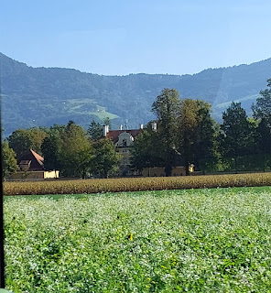

We also got a small peek of the centuries-old Abbey where Maria Von Trapp really lived and worked before she became a governess for Captain Von Trapp. Up on the hill in the background (photo below), you can see the Schloss Hohensalzburg on the left (big white fortress), and the Abbey is off to its right, with the red dome roof. It's known as Stift Nonnberg (Nonnberg Abbey) and is the oldest continuously existing nunnery in the German world. It began in the year 712 AD.

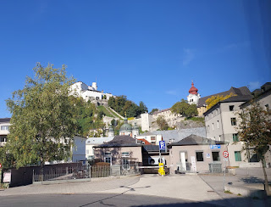

Next, it was off on a bus ride into the countryside to see Mondsee, a huge and beautiful lake surrounded by the town of Mondsee. In the movie Sound of Music, the Captain and Maria were filmed as being married in the Abbey of Mondsee instead of the Nonnberg Abbey. The reason why is that Nonnberg Abbey is still in use as a very sacred space. But in real life, they were married in the Nonnberg Abbey.

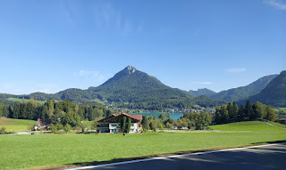

Video as we passed the Global Headquarters for Red Bull - for any energy drinkers out there: (15 seconds)

https://photos.app.goo.gl/a23bs438FwMWR3m26

Red Bull even has a huge football team in Salzburg. My boys both love energy drinks and thought it was pretty cool that we passed the HQ.

Gwen was my Bus Buddy for the day. We had a good time. XOXO

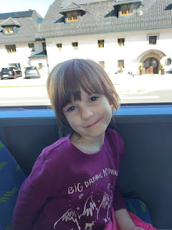

Mitch would lead us in singalongs from time to time. Sometimes it was only for 5 seconds, ha ha. But other times we would at least finish the chorus.

Video of us singing Do-Re-Mi: (21 seconds)

https://photos.app.goo.gl/ccRdYiKtWuFoZ6Qk8

Part 2 of Do-Re-Mi: (34 seconds)

https://photos.app.goo.gl/pgayMujkTZCDr4kn8

Mondsee and the lake . . .

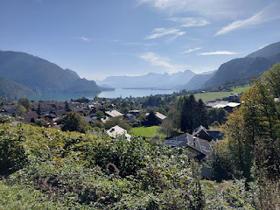

Three beautiful girls: Abby, Amber and Gwen

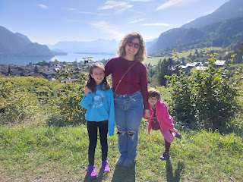

Video #1 of the beautiful view: (37 seconds)

https://photos.app.goo.gl/yAsZDzTFAoiGEsqo7

Video #2 of the view, including a paraglider coming in for a landing: (1 min, 44 seconds)

https://photos.app.goo.gl/cwjeLCCFFUdpZLLk6

A special rendition of "The Lonely Goatherd" by our favorite Mitch: (12 seconds)

https://photos.app.goo.gl/1gg5Q18zbkooaDSM6

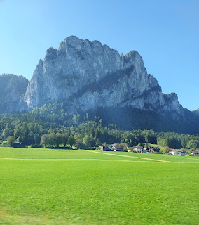

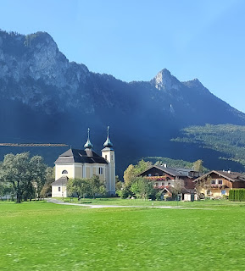

In the town of Mondsee sits the Basilica St. Michael. This is the Abbey where the Captain and Maria are married in the film. We had a full hour to wander and enjoy the town before meeting back at the bus.

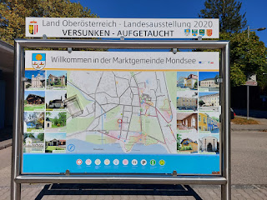

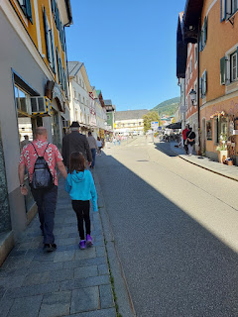

Basilica St. Michael in Mondsee . . .

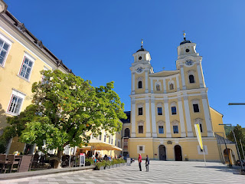

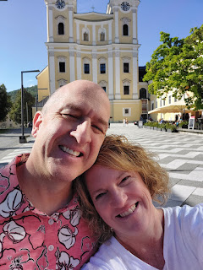

Mitch did a good job of telling stories during our bus rides from place to place. Sometimes he would just play the soundtrack from the movie and let us relax and look out the window, too. Scott liked the military stories that Mitch shared regarding Captain Von Trapp. The Captain was adamant about not joining the Nazi Regime, part of which was because Hitler had established a secret set of currency and he (Von Trapp) felt it would cause a financial ruin for their country.

Scott pointed out to the girls that there was a pattern on the ground, so they decided to only step on the darker squares . . .

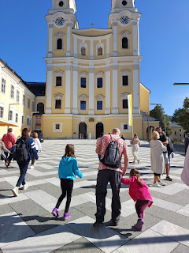

Inside the Basilica . . .

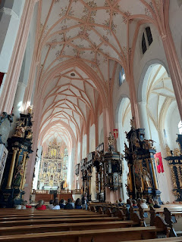

I thought it was interesting that you could purchase "holy water" . . .

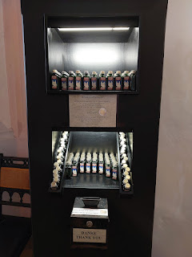

An old font for (I assume) christenings and baptisms . . .

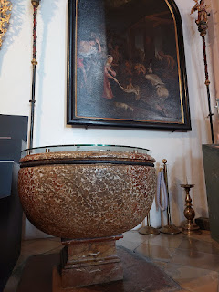

I loved seeing all the children's books (in German) that tell stories from the Bible.

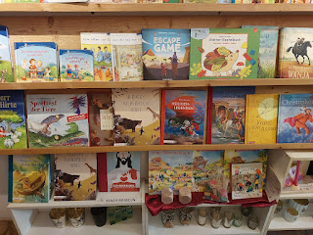

Gwen had a hard time switching gears at one point, bless her little heart. I was trying to get her to smile, but NOPE. :)

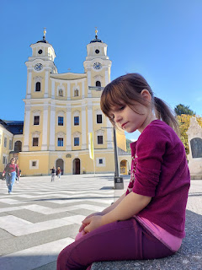

What DID help, was to find her slice of chocolate cake with raspberries on top.

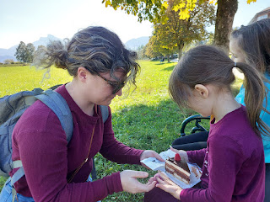

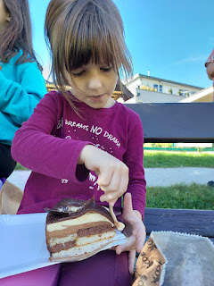

Abby chose some of the pretzel bread that we came to love. Sometimes it was long and skinny, but other times it was in a round shape like a donut (minus the hole). With a delicately salty and hard brown crust on the outside, the bread was soft and wonderful on the inside.

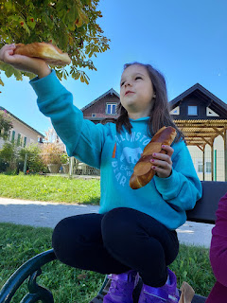

Video on our way back to Salzburg, with a documentary and behind the scenes for Sound of Music, hosted by the grown-up Liesl (Mitch's teenage crush): (34 seconds)

https://photos.app.goo.gl/jEuaQ9YeCmZwBBHW9

The last stop for the day was at Mirabell Gardens and Schloss Mirabel.

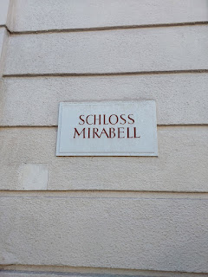

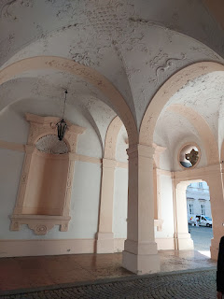

We saw 3 separate weddings going on at Mirabell that same afternoon . . .

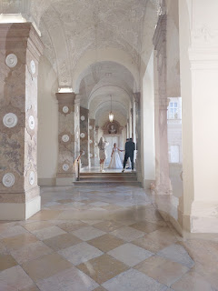

Video of a very cool floor map inside the Schloss: (7 seconds)

https://photos.app.goo.gl/XZcnbYy1ZQwDJoCQ9

Abby, Amber and Gwen . . .

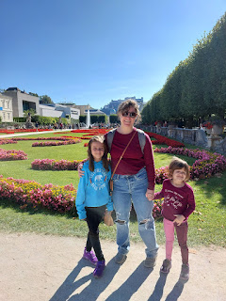

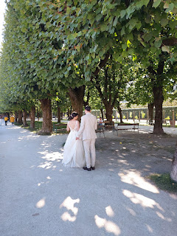

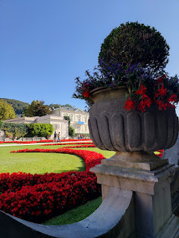

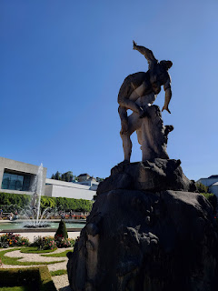

The love of my life . . .

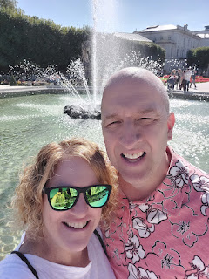

The girls had plenty of space to run and be wild and free. (Which also helped them fall asleep faster at night, ha ha)

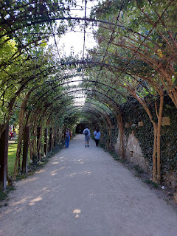

Video of Abby enjoying the long shaded tunnel: (6 seconds)

https://photos.app.goo.gl/V1HP5JeMpYy13F7b8

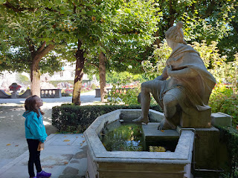

Shadow walking . . . Scott, Amber and me . . .

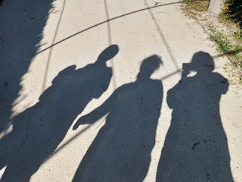

I couldn't believe how beautiful the flowers were in Salzburg in OCTOBER . . .

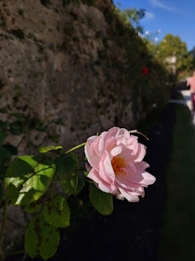

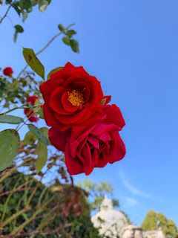

The fountain from the Mirabell Gardens . . .

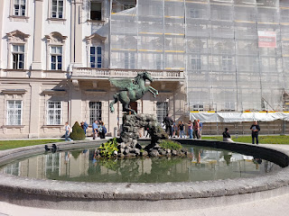

Once our 4 hour tour was done, Scott volunteered to stay with the girls at the playground while Amber and I went on a lunch date together. It's hard to find good food that both grownups and kids can enjoy, so we enjoyed our newfound freedom.

The cute place that Amber wanted to try would only accept cash payment and we didn't have very much on us, so we found another place around the block. It was a Mexican restaurant in Austria, ha ha. Talk about confusing with all the languages . . . we walked in and the lady greeted us in Spanish!!

Here is the menu - in German, Spanish, and English!!

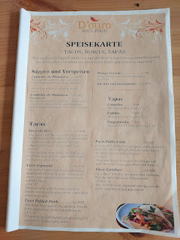

Yum. We had a good time visiting while the girls were having a good time with Papi. :)

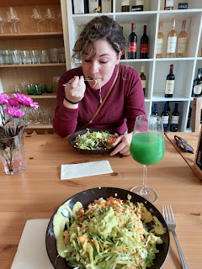

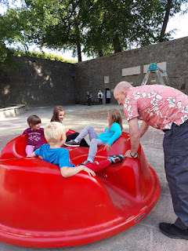

Video of him spinning the kids on the merry-go-round, much to their delight: (6 seconds)

https://photos.app.goo.gl/tkcSwox1VUc5p9So7

We brought some food back for him, which he ate while we waited for the girls to finish at the park. While we waited for our bus, the church across the street chimed exuberantly for us: (11 seconds)

https://photos.app.goo.gl/PvjWtZ9mGtA9Lnhc8

A bus ride home, and then a short walk up the hill to relax for a while. (*Note: we chose to ride the bus in and out of town so we didn't have to deal with traffic in an unfamiliar large city.)

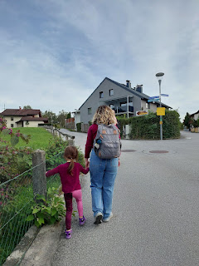

Sunset over the Untersberg mountains . . .

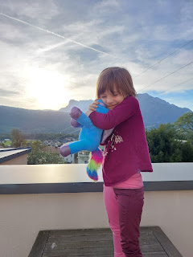

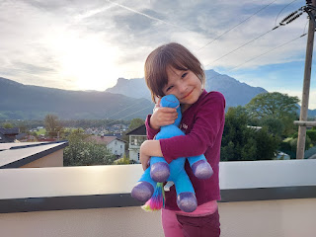

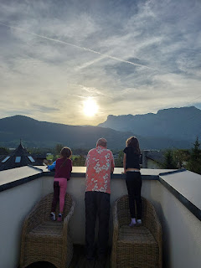

We walked down to the bus stop one more time after dinner. We had a special evening ahead!!

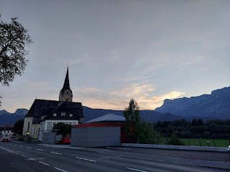

We had bought tickets months ago for the Sound of Music Marionette Show at the Salzburg Marionette Theater. Their puppetry is so masterful and culturally unique that it is on the UNESCO list in order to be preserved. We had front row seats, too!

On the lower steps: Abby, Scott, Amber and Gwen

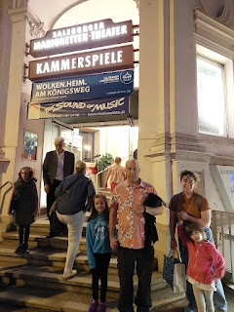

As we walked down the hallway to our theater, there were several glass cases with various puppets on display. They were very ornate and the detail-work was well-crafted.

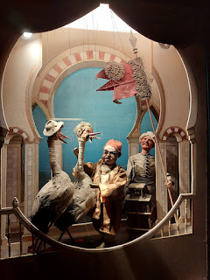

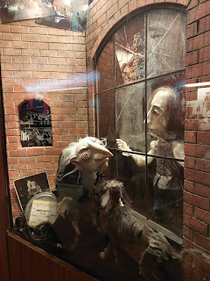

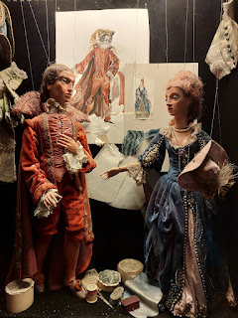

No photography was allowed during the performance, so we took a few photos before it began.

Video looking up at the beautiful ceiling high above: (16 seconds) (*Sorry if it makes you dizzy!)

https://photos.app.goo.gl/neb1xQYqj6m4xrmk8

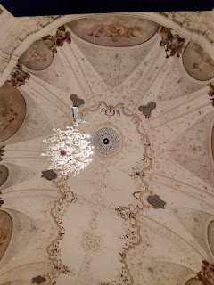

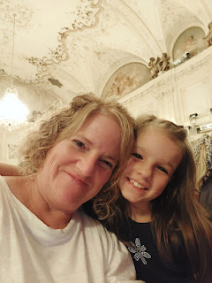

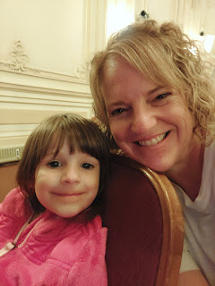

The show was absolutely DELIGHTFUL!!! In fact, I enjoyed it more than the bus tour that morning. It was also a hit with Gwen, who giggled too many times to count. The puppeteers were technical wizards, able to maneuver their puppet strings masterfully in and around each other, high above the stage. There was a great sense of humor throughout the show, even as they told a tale with highs and lows. The singing was also very beautiful and sounded extremely professional, like something out of a Disney movie.

After the performance, and while we were waiting for our bus, Gwen had some music in her that needed to come out. (53 seconds)

https://photos.app.goo.gl/Cym8PQeaevGfNUmo9

What a fantastic and full day.

Day Three (Oct 7th):

We hopped in the car to drive across the border into Germany. Two of Scott's siblings, Carol and Bev, recommended that we visit the Berchtesgaden Salt Mine, telling us how fun the experience is. We are so glad we went, because they were right!

Blurry photo, but basically it says we entered Deutschland.

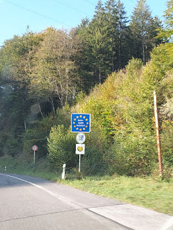

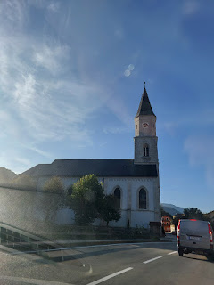

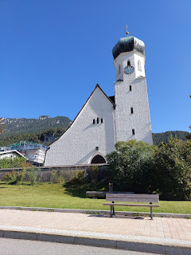

Video #1 driving around to the back side of the Untersberg Mountains into Germany: (40 seconds)

https://photos.app.goo.gl/ThvPazjNkSqF71Kx6

Video #2 of the drive: (56 seconds)

https://photos.app.goo.gl/t8GSdejjJWzQZczm6

When we arrived at the Salt Mine, we dressed in coveralls to help keep us warm. The temperature underground is a constant 11-12 degrees Celsius, even in the winter. (Equal to 51-53 degrees F)

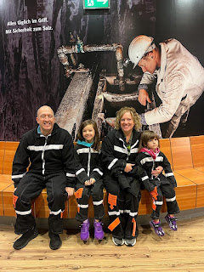

We learned later in the tour that the white stripes on our coveralls glowed in the dark!! Super cool.

We weren't allowed to take any photos or videos during the tour, for "safety reasons". I was bummed, but I fully complied this time. The best summary I can offer is this: An open-car train took us underground and dropped us off. We had English audioguides to listen to each time we got to a room that needed some explanation. There was a wooden slide to go down (70 meters I think). Gwen opted out of that, so I walked down the path with her while Scott, Amber and Abby rode down the slide.

A little bit later, we went down a second wooden slide (40 meters this time). Gwen was ready to try this one, so we all rode down together like a choo-choo-train. At the bottom was a beautiful lake, called Mirror Lake. A large wooden boat carried us all across while an entertaining light show made us ooh and aah. A few more rooms of info and learning, and then a train arrived to transport us back up to the light of day. It all took just over an hour from start to finish. We all enjoyed it, especially the slides, the lake, and the glow-in-the-dark coveralls!!

Walking back to the parking lot, we crossed over a beautiful crystal clear river. I loved listening to the sound of the water cascading along below . . .

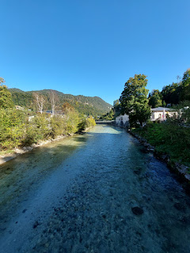

Video of the river sounds: (22 seconds)

https://photos.app.goo.gl/i8WvfzXPTH7yu4kA6

From there, we drove 25 minutes NW to Bad Reichenhall so we could tour the Old Salt Works Museum that was part of our tickets.  I've seen many cities on German maps named "Bad ____". Curious, I looked up what it means. It means "Bath". So there must be something associated with water with each of these places.

In the parking lot next to the Museum, there was a beautiful fountain. The girls ran right over to see it and to walk around it as many times as they could before we rounded them up to move along.

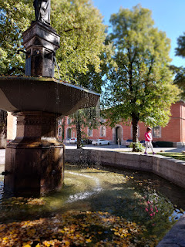

We found a spot across the street for lunch before starting our next tour. I ordered trout and seasonal vegetables. My goodness it was huge!! Scott had to help me finish it . . .

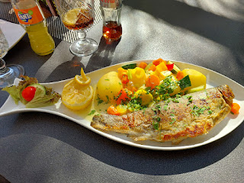

This next tour was all done in German, but they did give us 3 pages of English explanations for each room that we stopped in.

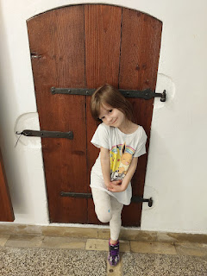

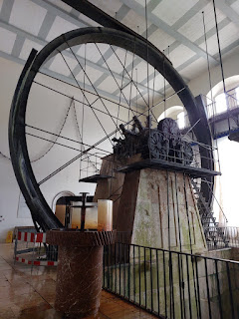

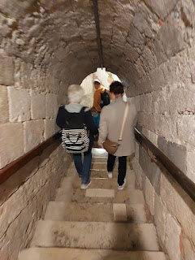

The steps going up and down into the old mine were made of marble, which made them more prone to being slippery. We had to be very careful. Oh - I can't remember if I mentioned this fun fact already, but Salzburg means Salt Castle, so this area of Austria/Germany has a long history with salt.

Also, I am currently in London as I type this, so I don't have access to the papers that we were given as part of the tour. I apologize . . . I may share something later on, though, when I get back to Italy.

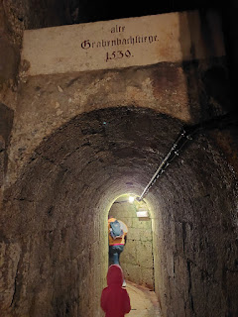

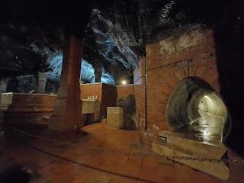

Reichenhall means "Rich in Mines." That it is . . .

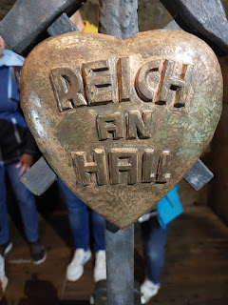

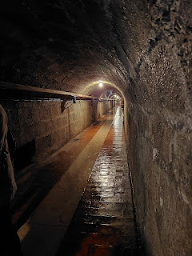

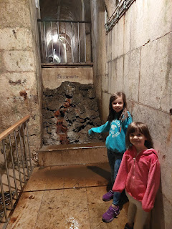

I love watching Scott when he's thinking hard and trying to figure something out, like how this old rusty pump works . . .

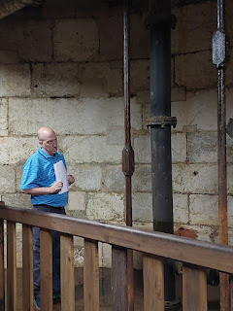

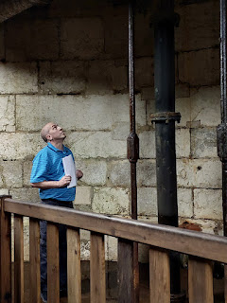

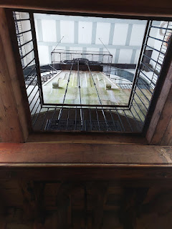

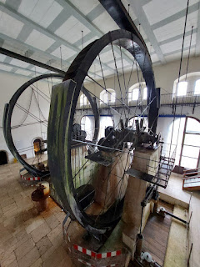

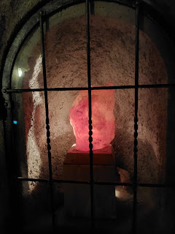

The salt mining process explained . . .

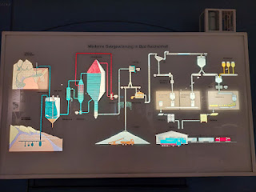

This map shows Salzburg, Berchtesgaden and Bad Reichenhall. They all sort of triangulate around the Untersberg Mountains. Salzburg is in the lower right, Berchtesgaden is on the left of the mountain range, and Bad Reichenhall is on the north side.

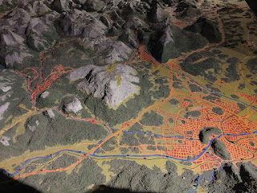

It was a lovely day in this little corner of Germany, learning about the old salt mining process together. As soon as we got back to our AirBnB, Scott packed up quickly so he could start the 5 hour drive home to Vicenza. He was needed in church the following morning . . .

Amber got out her watercolors and spent some quiet time out on the balcony painting the mountains and the peaceful view.

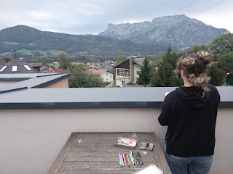

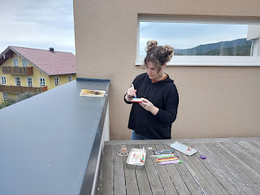

I laid on a lounge chair, listened to a General Conference talk and stared up at the sky full of clouds . . .

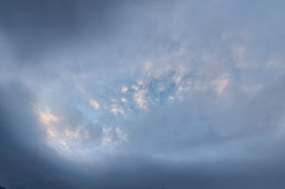

Day Four (Oct 8th):

We drove about 20 minutes to get to the nearest Church of Jesus Christ of Latter-day Saints. We had a spot of trouble getting out of our neighborhood at first, because there was some sort of procession and the police had the roads blocked off. It looked like Google Maps had an alternate route for us, so we decided to try it. It ended up taking us up into the nearby hills on a gravel road, and then it wanted us to turn onto a dirt road that looked more like a walking trail into the forest . . . um . . . no thanks. We turned around and headed back to the blocked intersection, where we only had to wait about 2-3 minutes before the road opened back up to traffic.

We heard a cannon go off and saw the smoke from where we were just around the corner during those couple of minutes, though. I did a little research later to figure out what the procession was all about. It was a Thanksgiving celebration, to celebrate the Fall Harvest in Puch-Hallein. Many of the bystanders were in traditional dress.

We made it to church and we were only 2 minutes late! Amazing. (*We took this photo AFTER church and after we had changed out of our dresses and into some casual clothes.)

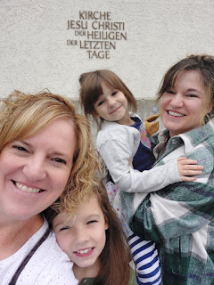

I will never tire of singing hymns in German. It always warms my heart and brings joy to my soul.

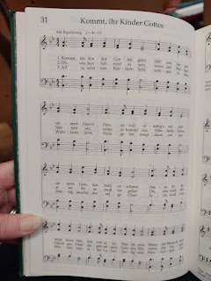

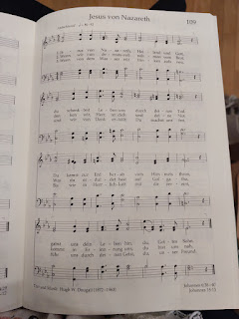

It was Fast and Testimony Meeting, which is usually the first Sunday of the month, but General Conference pushed it back a week to this day. This is a Sabbath Day where members of our church fast for up to 24 hours, by going without food or drinks. It is a time to reflect on spiritual things instead of physical needs. During Testimony Meeting, we have an opportunity to share our thoughts and feelings about how the Gospel of Jesus Christ has helped us and blessed our life. It is so uplifting to hear each other share deep and personal insights.

I tried to get Google Translate to help me understand all the German testimonies being shared. Sometimes it worked, and sometimes it didn't do anything. (There is a microphone option in the app.) But here are a few sweet thoughts that I got through the app from a few different people.

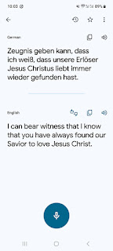

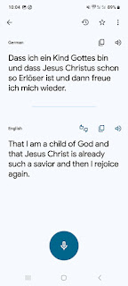

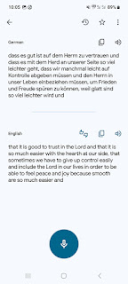

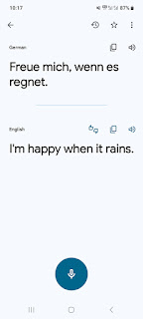

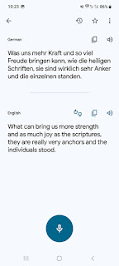

The closing hymn . . .

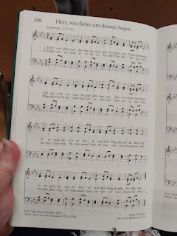

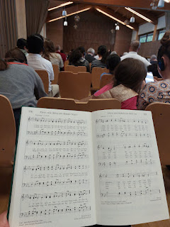

There was a family in front of us with headphones on - something we arrived too late to get for ourselves. Missionaries often translate the services into English or other helpful languages. After Sacrament meeting finished, I introduced ourselves to the family, because I heard them talking in English to each other. Turns out, they just moved to Germany a month ago from the U.S. We had so much fun chatting, we ended up exchanging phone numbers! And we are also related!! I thought for sure we were related through my Dad's line, since we both had Mennonite ancestors from Germany that immigrated to Lancaster, PA. But it turned out we were related through my mom's line!! (click photo below to see it more closely)

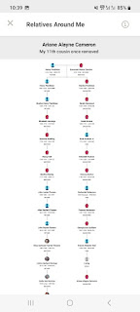

We hope to keep in touch while we're both in Europe. :)

Next, I drove us into town so we could get a bite to eat before our special ballet performance.

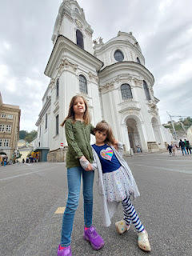

Mozart was born in Salzburg and we got to walk past the house where he was born. ("Geburthaus")

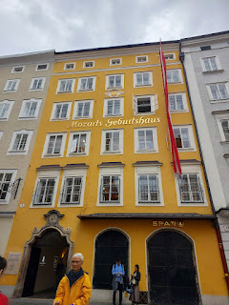

Nearby is a pedestrian bridge, known as the Mozart Bridge.

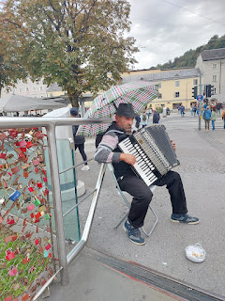

There are thousands of locks attached to the links on the bridge, a cute trend across the world that I've seen. People bring a lock and write something on it to profess their love, and then take a photo together at the spot where they locked it up "forever".

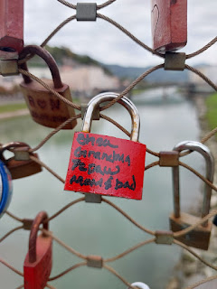

Amber, Gwen and Abby on the Mozart Bridge . . .

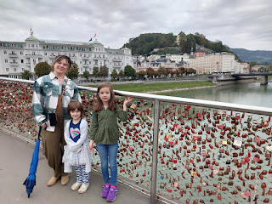

The girlies and me . . .

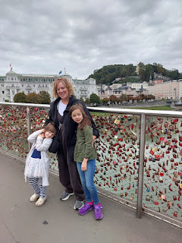

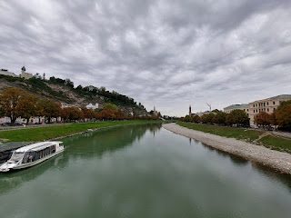

Gwen and I enjoyed looking at all the locks.

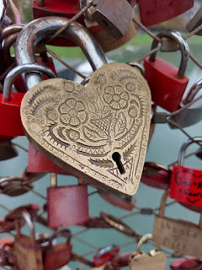

We hunted for a good lunch spot, but in the interest of time leading up to the ballet performance, we settled (yet again) for McDonald's . . . blech. They try so hard to make it look fancy on the outside, but really it's just the same old stuff no matter where you go.

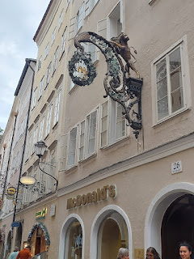

We loved seeing all the cute things in the storefront windows as we walked to the Great University Hall of Salzburg.

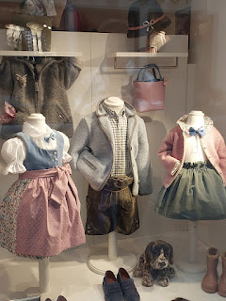

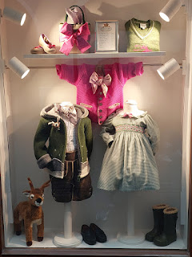

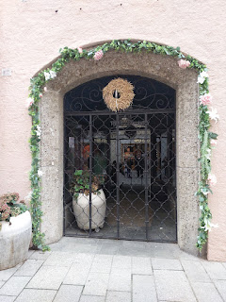

We were so excited to see the Cinderella Ballet, accompanied by the Salzburg Philharmonic. The girls got their picture taken with one of the Ball Maidens from the performance right before we went in to take our seats.

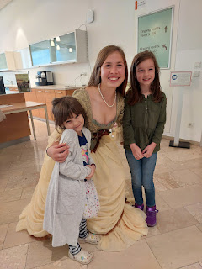

Inside the theater were several beautiful paintings and some very classy decor.

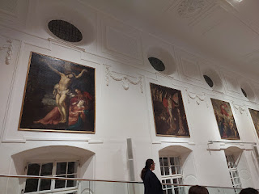

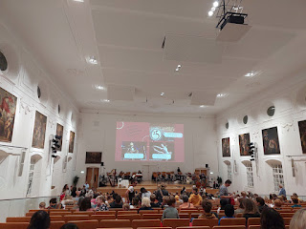

The Ballet involved a large screen that projected the "scene" up on the wall, the Philharmonic at the back of the stage area, and the dancers in front.

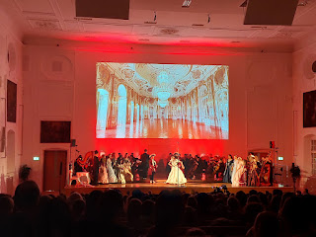

When the Prince was trying to locate the owner of the glass slipper that was left behind at the Ball, a few members of the Philharmonic joined in to see if they might be so lucky in marrying the Prince, ha ha. And then, the Prince came up into the audience with her servant to see if one of US was a perfect fit!! He even came all the way up into the nosebleeds where we were sitting . . . .

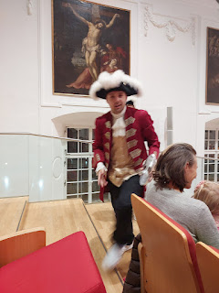

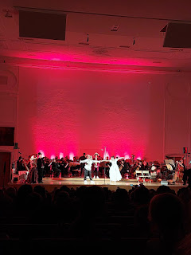

Short video of Cinderella dancing with the Prince: (5 seconds)

https://photos.app.goo.gl/g3hgYz1GeBpJLZqW6

It was a very clever performance, with a lot of interaction with the children seated in the audience. We had such a wonderful time.

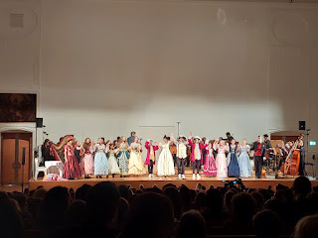

After it was all done, we let the girls run off some excess energy outside in the park. Gwen was upset 2/3 of the way into the show because anytime there was a bit of dialogue, it was always in German, which she didn't understand. Amber took her out for the last few minutes and that seemed to help.

Maybe hugging a giant pickle statue was helpful, too.

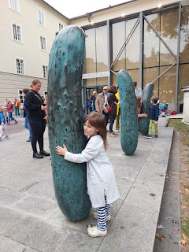

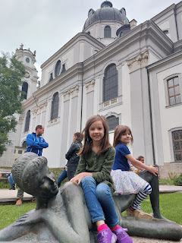

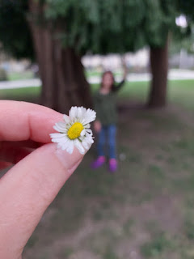

Finding Gwen some tasty cheesecake in a little cafe also did wonders for her mood . . .

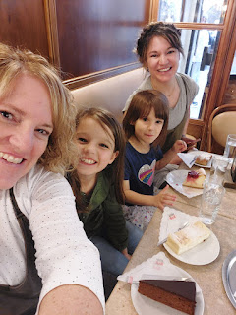

There is an interesting phenomenon in Salzburg called Mozart Balls. They are a fancy chocolate ball with bits of pistachio and nougat inside. I picked up a 2-pack to bring home to share with my new friend, Christine.

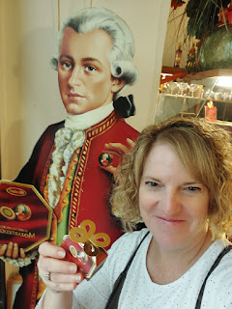

It sprinkled off and on as we wandered Old Town Salzburg for the rest of the afternoon. But that didn't stop us!

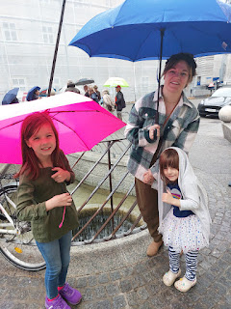

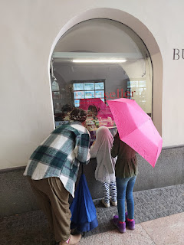

When I saw this store display of dozens of tobacco pipes, it brought back a lot of good memories of my Grandpa Linton Norman, who regularly had one in the corner of his mouth, along with a twinkle in his eyes.

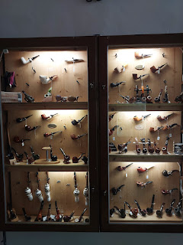

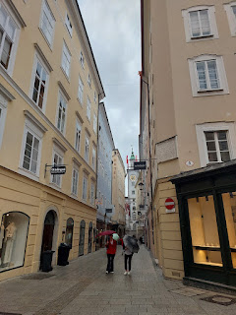

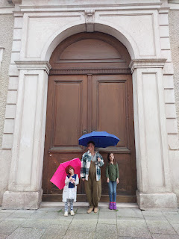

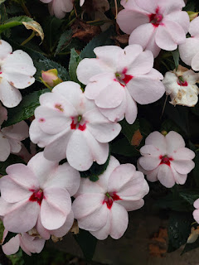

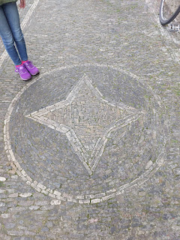

Video of a horse-drawn buggy passing by: (6 seconds)

https://photos.app.goo.gl/gdN2N1td5Yuomcbf7

Video of the large square we found, with a huge and beautiful fountain: (6 seconds)

https://photos.app.goo.gl/7Lmrirry2xGggAi69

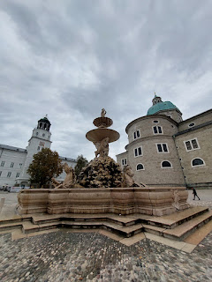

Video of the fountain's majesty: (7 seconds)

https://photos.app.goo.gl/QmTBLVPixSbMyf3e7

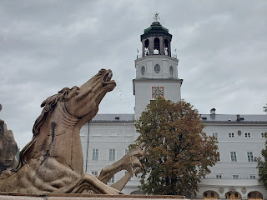

The girls did their usual loops around the fountain for a while: (8 seconds)

https://photos.app.goo.gl/15RA6ec5DSJL4Xd79

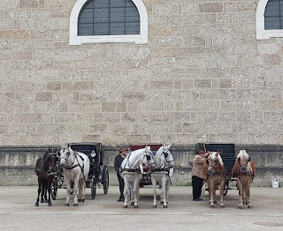

Next, we found the Salzburg Cathedral. Online, we read that the cathedral was free to visit. But, in fact, we had to pay $10 for the 4 of us to get in . . .

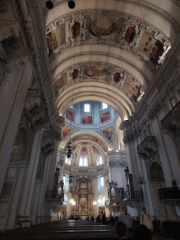

It was pretty spectacular, so I guess it was okay that we had to pay.

I followed Gwen around, making sure she didn't get into any trouble . . . (8 seconds)

https://photos.app.goo.gl/TdKZZyE7x25brQoeA

Abby and Gwen, taking it all in . . . (10 seconds)

https://photos.app.goo.gl/rohsacUKM2pvKEtE7

There were a few musicians warming up for an evening performance, including these 2 harpists. Too bad we wouldn't be staying in town that late. (24 seconds)

https://photos.app.goo.gl/yWAJUCepxouRkfSe8

As we got closer to where we parked in the parking garage, I saw just how close we were to the Schloss Hohensalzburg. Wowza.

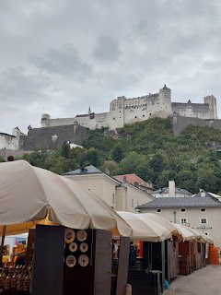

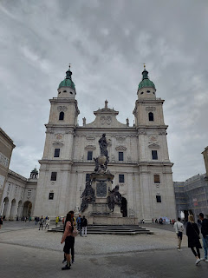

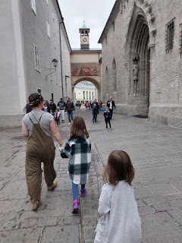

Finally, we made it back to our AirBnB on the southern outskirts of town and cooked up some miscellaneous leftovers so we could empty out the fridge. I also took one last quick walk down the hill because I really wanted to see the cemetery at the old church by the bus stop that we frequented so many times.

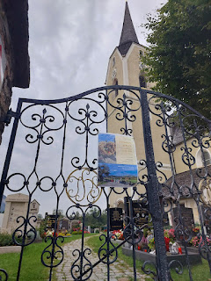

I was immediately impressed by the beauty of each grave. Clearly, there is a lot of love and attention being given to each one. And by each one, I mean each person. XO

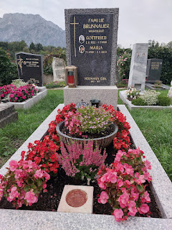

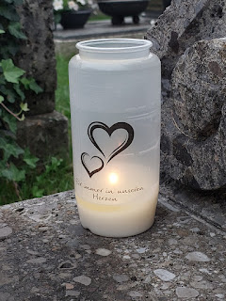

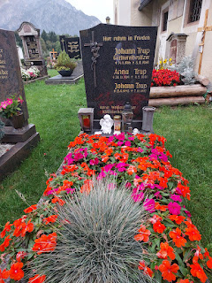

Video #1 of the cemetery: (6 seconds)

https://photos.app.goo.gl/J2kEsySFRVwuR4Pn9

Video #2 of the cemetery: (5 seconds)

https://photos.app.goo.gl/r7x7AdSvtFgGKqJeA

Video #3 of the cemetery: (11 seconds)

https://photos.app.goo.gl/AyeYts64GPFnsumCA

The flowers in the neighborhood were equally beautiful and I enjoyed this one last adventure before we packed up to leave in the morning.

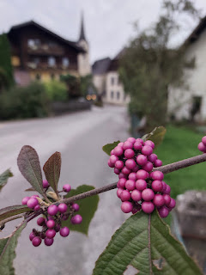

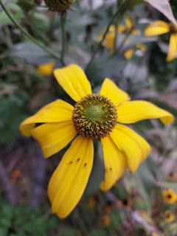

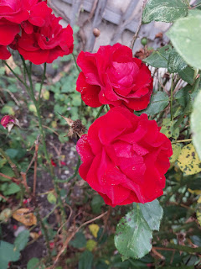

Day Five (Oct. 9th):

It was a sad day to have to leave such a classy place, but it was time to go. We made our way south to Italy, stopping halfway in Villach for lunch and a little bit of shopping at the Villach Atrio Mall. (Villach is very close to the Italian border.)

The girls were so excited to pick out some Halloween-themed donuts to snarf.

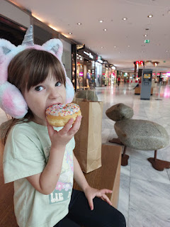

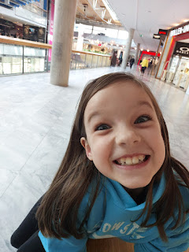

We also made one more stop on the way home. We found a nice park to set up as a meeting place for a visit with Kylie and Avery, but unfortunately they weren't able to make it. Abby and Gwen were still happy to have a place to run and climb and be free from the car for a while, though.

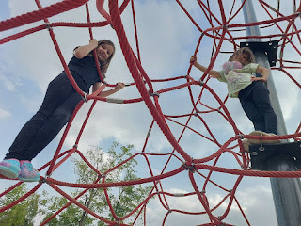

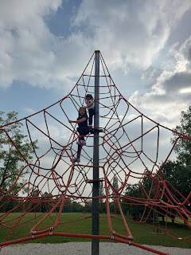

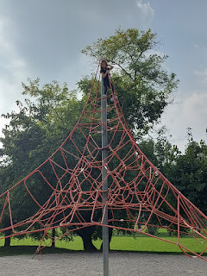

They also figured out a new toy at the playground: (20 seconds)

https://photos.app.goo.gl/yeyTu9Zwhw7jCM7U7

And we made it home safely, jiggety jig.